Towards a Fruitful Life MOOC
Hopes and challenges of Women with Disabilities in the Arab World

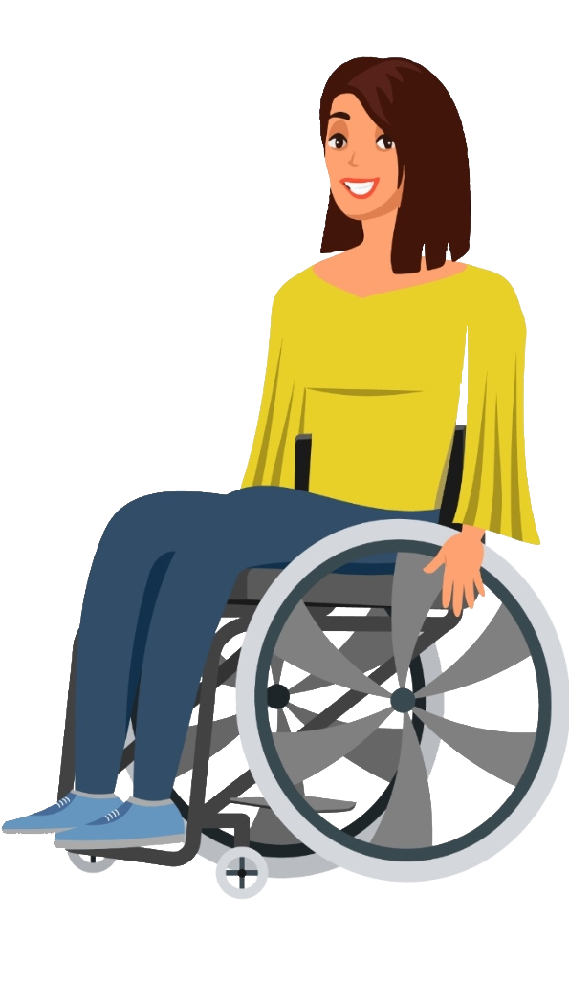
Technical Guide

- Course tools 2
- Change language 2
- Resize text and Change page colors 2
- Upload Images 4
- Navigation 5
- Navigation bar (Bar on the left) 5
- Resources(Content under every video) 5
- Find transcripts 6
- Every Icon Meaning 6
- Account and profile 7
- Access the profile 7
- Correct name 8
- Change profile picture or delete it 8
- Add private infos (ID number, Phone, Address, Webpage) 9
- Change Password 9
- Certificate 10
- Forum Post 10
- Start of every week 10
- Me in brief 11
- Add a post 11
- Add picture to me in brief 12
- Me in brief is opening user's profile 12
- Delete or Edit post 12
- Resources content 13
- Add a comment 13
- PDF zooming 13
- Web Page Zoom 13
- Open in a new tab 14
- Download Word or PDF 14

Course tools

Change language
To change the language, click on the desired language in the "Change Language" block located at the right as highlighted in the image below.
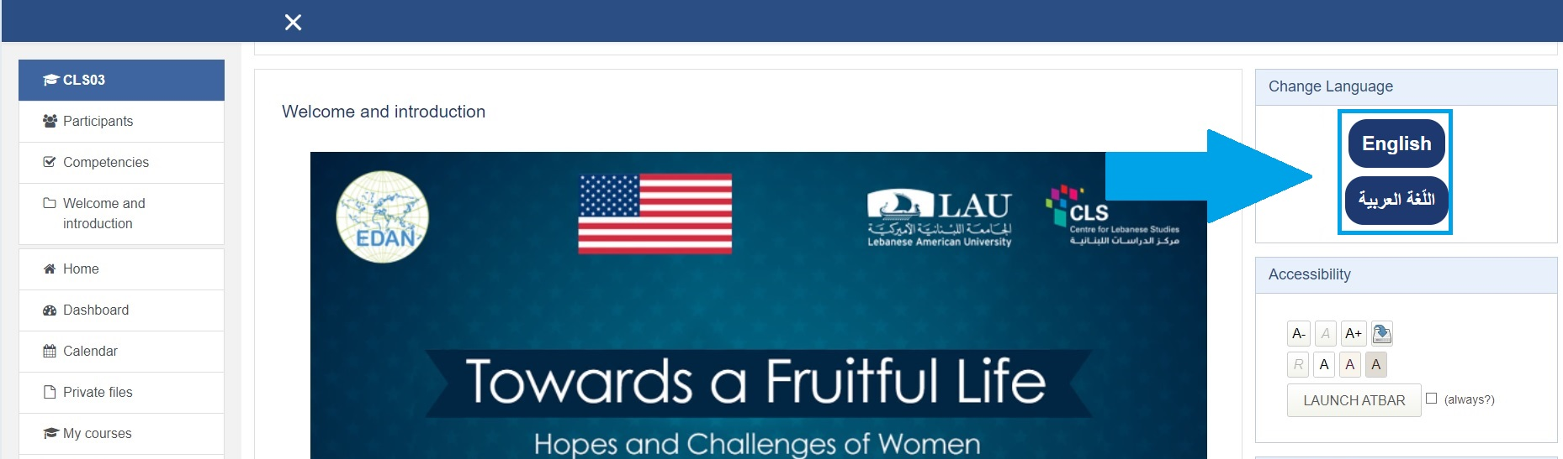

Resize text and Change page colors
- To increase the text size press several times on "A+" located in the "Accessibility" block located at the right as highlighted in the image below.
- To decrease the text size press several times on "A-" located in the "Accessibility" block located at the right as highlighted in the image below.
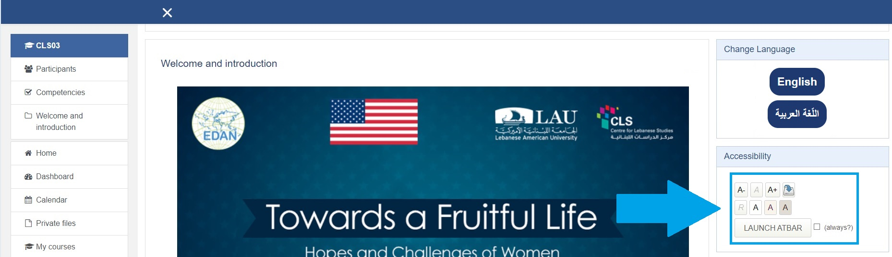
- There are 3 choices of text and background colors available.
Those are displayed on the icon in the Accessibility block located at the right as highlighted in the image below.

Upload Images
- Press on the Document Icon as highlighted in the image below. Or you can drag the image from its location into the area marked with a blue arrow.
- If you chose to press on the icon. Then now press on “Upload a file”.
- Press on “Choose a file”.
- Press on “UPLOAD THIS FILE”.
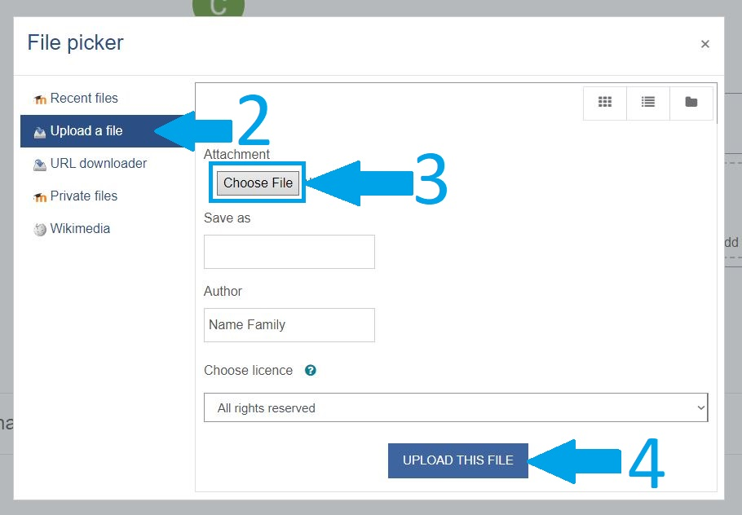
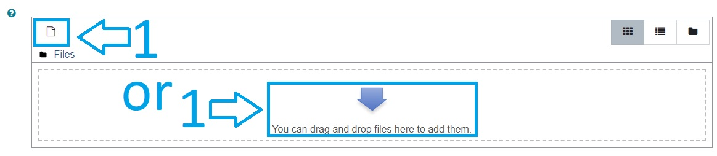

Navigation

Navigation bar (Bar on the left)
- You can open it if closed by pressing on the 3 dashed lines located at the top left. And close it by pressing on the X in the top left.
- Pressing on the first cell named ”CLS” highlighted in Blue opens the "Homepage" of the current course.
- The participants' cell opens a page containing all participants of the current course.
- Badges and competencies are not available for this current course.
- Pressing on "Welcome and introduction' opens the home page at this section if pressed within an activity and navigates you to this section if already in the home page.
- All the weeks are located on the left panel and by pressing on a certain Week it opens the home page at this Week if pressed within an activity and navigates you to this section if already in the home page.

Resources(Content under every video)
Every main video has a number of resources following it and related to the subject of that video subject. Those resources cannot be accessed unless their video is marked as “Done”.

Find transcripts
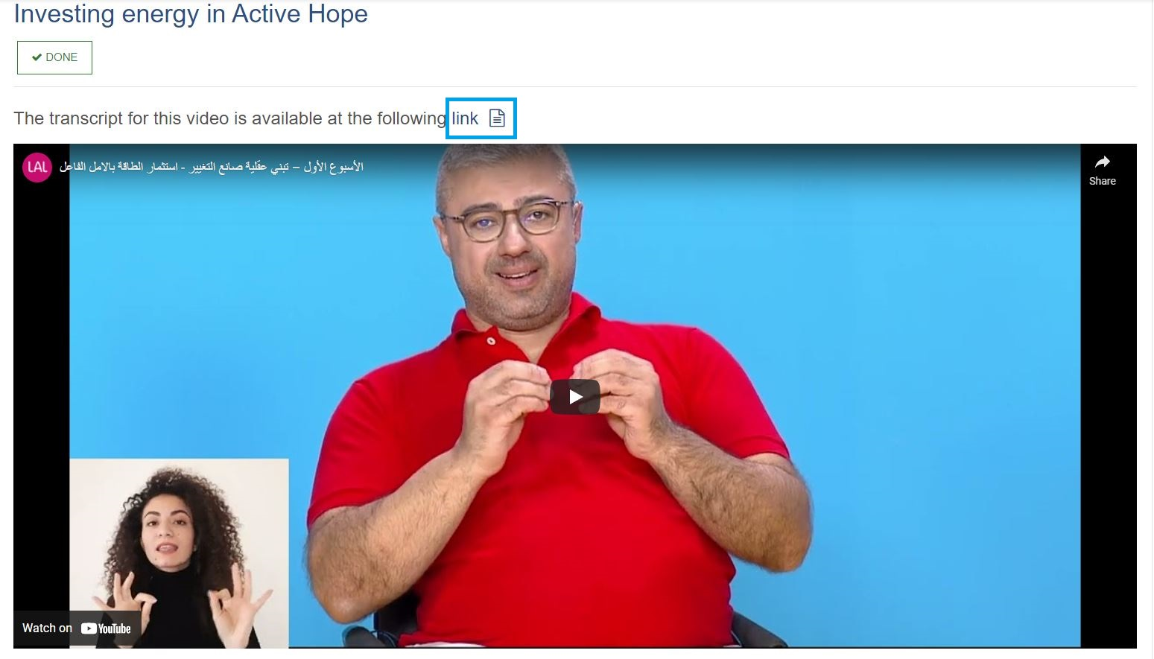
You can download a Word version of the transcript of every video by pressing on the word "transcript" highlighted in dark blue.

Every Icon Meaning
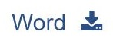
- The Youtube icon belongs to the titles of the main videos.
- The Word Download allows you to download a Word version of the PDF shown in the current activity.
- The PDF Download allow you to download a PDF version of the PDF shown in the current activity
- The Open New Tab allow you to open in a new tab the Webpage shown in the current activity

Account and profile

Access the profile
- Press on the drop down menu icon on the right of the profile picture located at the bar at the top of the page
- Press on "Profile"
- Press on "Edit profile" in the "User Details" cell
- Any change made here will only resolve if you press on "UPDATE PROFILE" at the bottom of the page
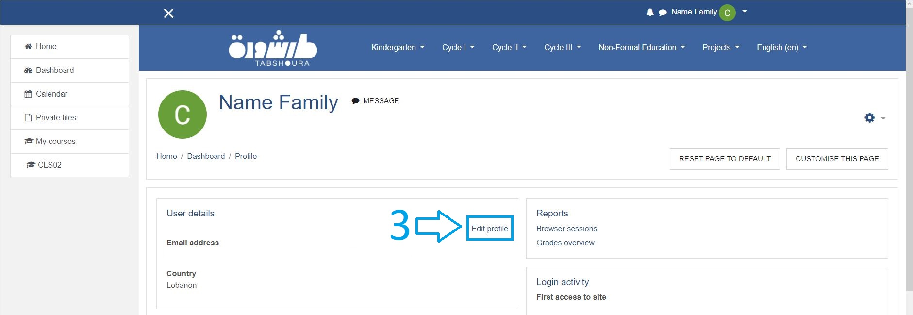
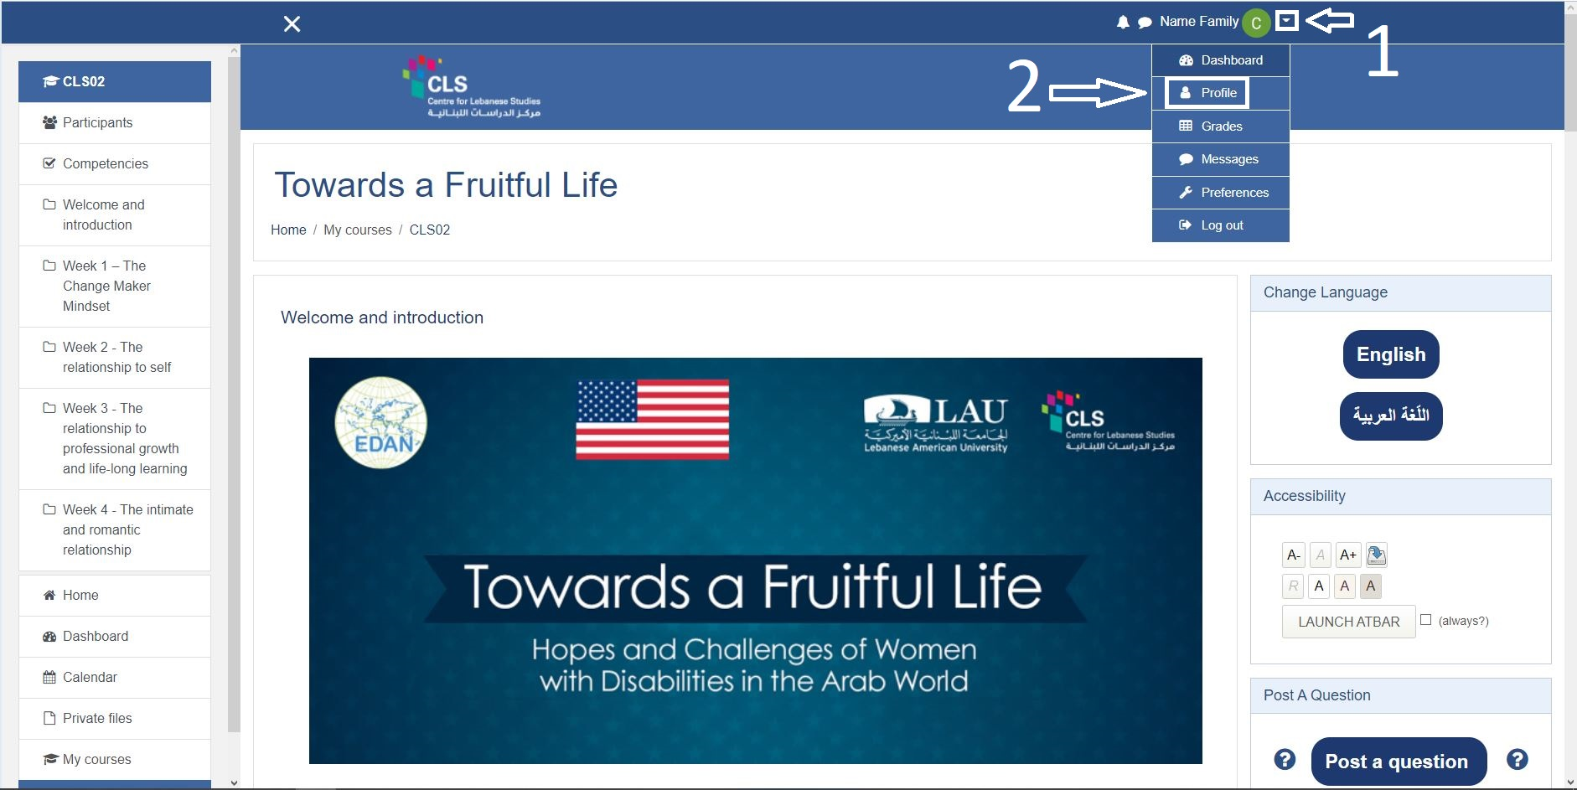

Correct name

- Go to Edit profile as shown above in "Accessing the profile"
- In the first 2 cells you can correct your Name and Family Name
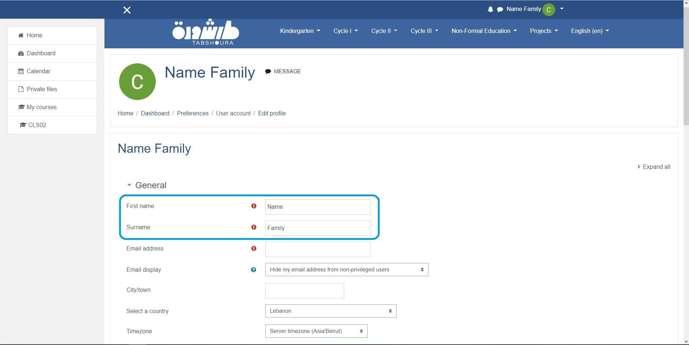
- Press on "UPDATE PROFILE" at the bottom of the page

Change profile picture or delete it
- Go to Edit profile as shown above in "Accessing the profile"
- Scroll down to the section named "User picture"
- If you desire to delete the picture, you can check the "Delete picture" box, if not continue to step 4.
- You can drag the picture you desire into the section with a blue arrow or press on the file icon highlighted in the image below. As demonstrated in the section Upload Images
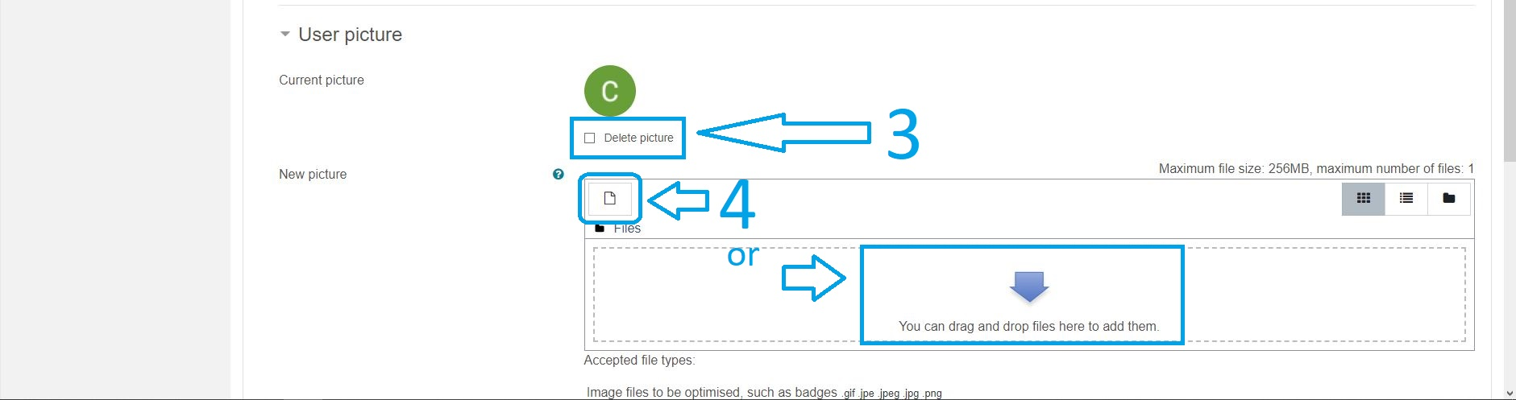
- Press on "UPDATE PROFILE" at the bottom of the page.

Add private infos (ID number, Phone, Address, Webpage)
- Go to Edit profile as shown above in "Accessing the profile"
- Press on "Optional" to add your private infos if desired.
- Press on "Other fields" to add a Web page to your profile
- Press on "UPDATE PROFILE" at the bottom of the page.

Change Password
- Press on the drop down menu icon on the right of the profile picture located at the bar at the top of the page.
- Press on "Profile".
- Press on the "Settings" button located at the top right.
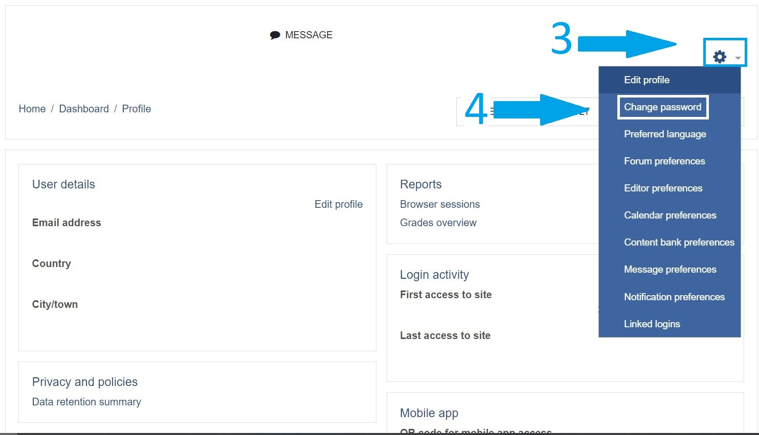
- Press on "Change Password".

Certificate
To be eligible for a Certificate, You must pass in all the quizzes, and fill all the questionnaires(Pre-course and Post-course). After that press on Certificate at the end of Week 5 to get your Certificate.

Forum Post
To check everything you posted like in "Me in brief" or "Post a question"
- Press on the drop down menu icon on the right of the profile picture located at the bar at the top of the page
- Press on "Profile"
- Press on "Forum posts" located in "Miscellaneous" cell

Start of every week

For the “CL03” course, start dates for every week are set as follows:
- Week 1: Thursday, July 14, 2022
- Week 2: Thursday, July 21, 2022
- Week 3: Thursday, July 28, 2022
- Week 4: Thursday, August 4, 2022
- Week 5: Thursday, August 11, 2022
For participants who will follow the course afterwards, they can move to the following week as soon as they have completed the previous week's videos and quiz.

Me in brief

Add a post
- Press on "ADD A NEW TOPIC"
- Add a Subject, its private and won't be shown to others
- Add your Message
- Add your picture if desired
- Press on "POST TO FORUM"

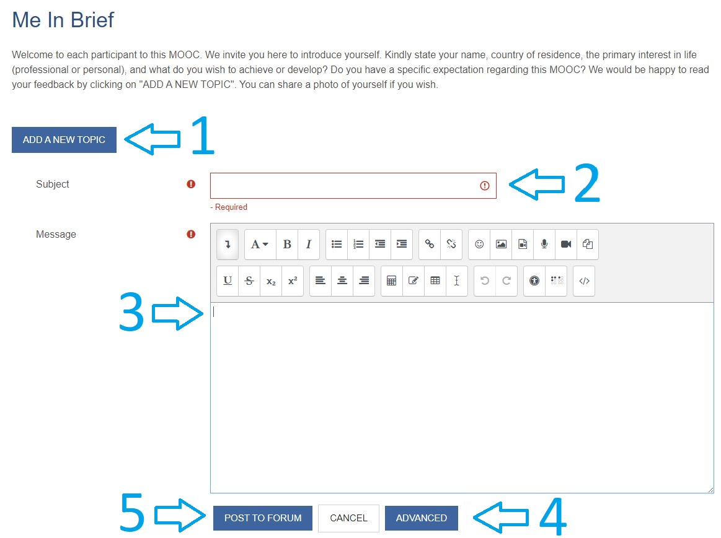

Add picture to me in brief
To add picture to the post:
- Press on "ADVANCED"
- You can drag the picture you desire into the section with a blue arrow or press on the file icon. As demonstrated in the section Upload Images

Me in brief is opening user's profile
This happens when you press on the name. Press on the picture instead to see the User's post.

Delete or Edit post
- Open your post by clicking on your post profile picture.
- Then press Delete/Edit

Resources content

Add a comment
If the comments are not located at the right, they are located at the bottom.

PDF zooming
To zoom in the PDF, press on the + sign as highlighted in the image. To zoom out the PDF, press on the - sign.
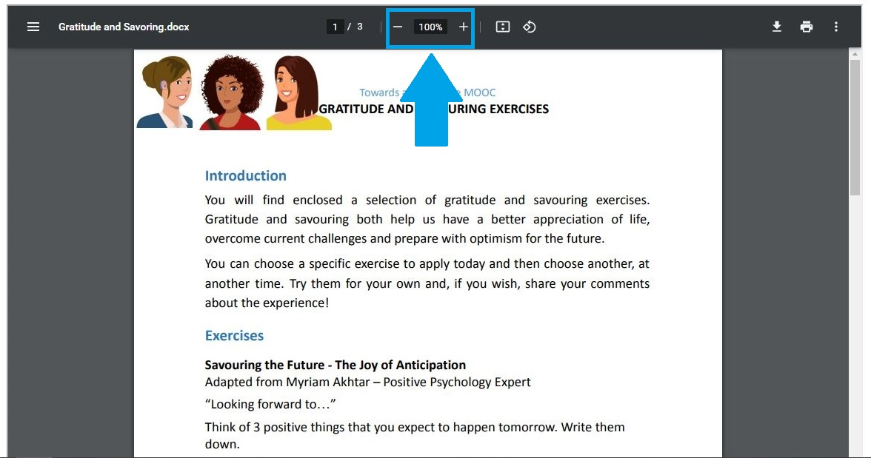

Web Page Zoom
Zoom in the browser to Zoom in the Web page.

Open in a new tab
Press on the External Link icon located at the top right of the page to open the Web Page in a New Tab.

Download Word or PDF
- To download the Word version of the PDF displayed, press on the Word download button located at the top right of the page.
- To download the PDF as it is, press the download button of that PDF as highlighted in the image below .
