Examine the materials below and think about how each one may or may not be useful in building a model of an artificial arm.

**Materials**

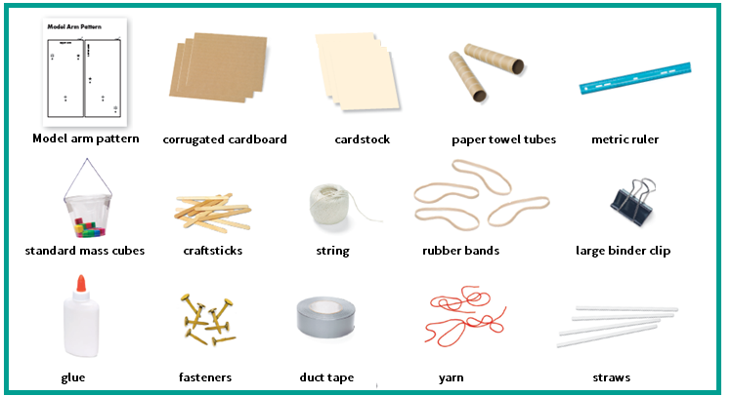

Draw a design of your artificial arm.

What are your design constraints? Describe two different ways you could combine some of the materials to solve the problem.

Draw a design of your artificial arm after improvement.